Plan-It!© USERS GUIDE – V6.0

WELCOME TO THE Plan-It!© CAPITAL PLANNING SOFTWARE

For use with Microsoft Access 2013, 2016 or 2019/Office 365

USER NAME ____1_____
PASSWORD __ plan ___

PATH LOCATION OF DATA FILE ______________________________________ (for future reference)

Plan-It System Requirements:
- Microsoft Access 2013 or later
- Runtime Access 2013, 2016 or 2019 is also an option
- Both 32-bit and 64-bit versions of Access may be used
- Windows screen resolution of 1024 x 768 pixels or more
- A data file location on your server that gets backed up frequently

Plan-It Installation (Assumes MS Access is installed on each user’s PC):
Plan-It has one file that should be placed on your C:\ drive (called ‘PlanIt2000.mdb’) and one file that needs to be put in a folder where it can 1) get backed up regularly, and 2) be accessed by all users (called ‘Si_dat.mdb’).
Step #1: Install Data File. You may pick whatever server drive you want to use - one that all users can access. Create a folder called “PlanIt”. Place in this folder the ‘Si_dat.mdb’ file (for example, place it in the location G:\PlanIt for a server of drive “G”).
Step #2: Create Graphics Folder. Create a location for your graphics files (e.g., G:\PlanIt\Graphics).
Step #3: Install Application File. On each authorized PC, create a folder called “C:\PlanIt”. Copy the ‘PlanIt2000.mdb’ file to this location.
Step #4: Create Desktop Shortcut Icon. Create a shortcut to run the “C:\PlanIt\PlanIt2000.mdb” file.
Step #5: Run Plan-It. Double click on your desktop shortcut icon. The first time you enter Plan-It it will not know where the data file has been located. It will ask you for the path. Type in the path (e.g., G:\PlanIt) and it will automatically link the application to the data. This must be done on all PCs that are authorized to use Plan-It. At the opening screen, type the User Name and Password (shown above for reference) and begin!

Plan-It Upgrades:
Plan-It is sold on an annual license basis. You will receive a call a couple months prior to your expiration date to arrange the sending of the upgrade files. Full instructions will be given at that time.

YOU ARE READY!

To run Plan-It from Windows Explorer, double click on the ‘PlanIt2000.mdb’ file name (or your desktop icon) and it will begin.

HINT: make sure you create a shortcut on your desktop that takes you to Plan-It automatically. For help in getting this icon on your desktop and renaming it, talk to Strategic Insights.

LOGGING IN:
The first screen in the application, the Opening Screen, is used to log into the system. There are only a limited number of fields, as it is only used to ensure login security.
- ‘User Name’ - Type your user name.
- ‘Password’ – Type your password.
- ‘Serial #’ - This is customized for your site for future technical support reference.
- Finger icon – Takes you in to the next screen.
- Door icon – Takes you out of Plan-It.
NOTE: You have the option of either turning off the need for a user name and password, or enacting ‘user-level’ security. See later in the Users Guide for instructions on doing this.

OPENING SCREEN
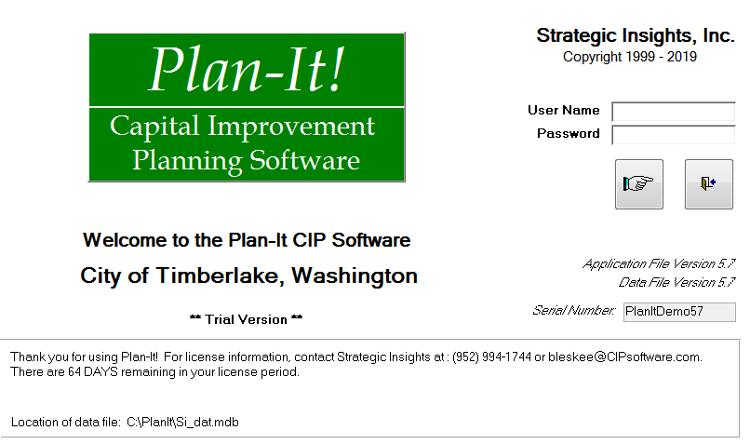
ENTER Plan-It!
LOG-IN FIELDS
LICENSE COUNTDOWN
DATA FILE LOCATION
EXIT Plan-It!

Plan-It License:
Plan-It is purchased under the agreement that a license fee is paid annually. The countdown is set to go from “365” to “0” as the end of your license period approaches. Two months prior to your expiration date, you will be notified by Strategic Insights and reminded to renew your license. Renewal entitles you to a new version of the application, including any additional features that have been added to the base system (an upgrade). If your license period expires, users will not be able to enter the application beyond the Opening Screen. If this happens, contact Strategic Insights for license renewal and entry into the system.

Plan-It Data File Location:
The Plan-It data file (named “Si_dat.mdb”) should be placed on your server so it gets backed up regularly. This feature tells you where your data file is, just as a reminder. Upgrades often need to add or change the data file, and this will tell you where the upgrade utility should look for the data.

YOU ARE NOW READY TO START ENTERING DATA!

SETTING UP PLAN-IT:

Click on the ADMINISTRATION tab. This screen is used to define terms and the data structures that suit your organization. The screen is divided into two data entry areas.
- The top area allows you to enter text that can be viewed by any logged-on user. Entering text here is optional – ignoring these functions in no way prohibits the use of other functions. By clicking on the tabs, you can add:
- Vision/Goals – Document the overall purpose of the Plan and how it fits your broader vision.
- Policies – Document various purchasing, management or other policies unique to your organization.
- Process – Document for future reference the steps taken in the Plan process.
- Process Calendar – Use it as a bulletin board to post key deadlines in the Plan process.
- Settings – There are two tabs within the Settings tab:
- User Settings: Allows user to switch to a different Plan-It data file
- System Settings: Allows users to do three things - activate specific sets of reports that were designed for select customers, set default graphics and documents folders or turn on ability to add ‘General Plan Consistency Score’ text for each project in the Data area.
- Security – You either turn off log-in security or set up ‘user-level’ security. There is more information found later in this Users Guide concerning these security options. Contact Strategic Insights to know how to access this area!
- Manage Graphics – Add, edit or delete link to all project graphics
- Enter ‘Actual’ Expenditures – Select projects and add values you want to show in the “Actual” column in ‘Budget vs. Actual’ reports.
- The bottom area contains tabs that open various important data tables. These are vital to being able to utilize other features of Plan-It.
TOP:
TEXT ENTRY, VARIOUS SETTINGS AND OPTIONAL SECURITY
ADMINISTRATION TAB
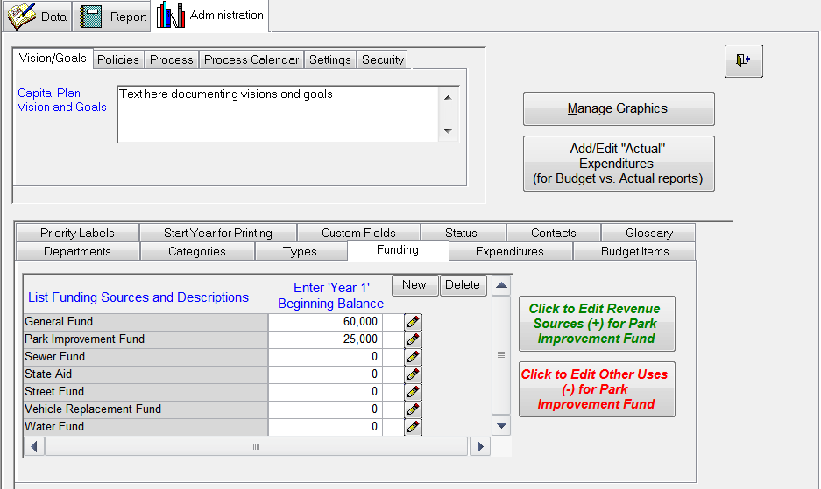
BOTTOM:
SET UP THE DEFINITIONS THAT APPLY TO YOUR ORGANIZATION
ADD “ACTUAL” VALUES FOR USE WITH “BUDGET vs. ACTUAL” REPORTS
ADD, EDIT OR DELETE PROJECT GRAPHIC LINKS
ENTER DESCRIPTION FOR EACH FUNDING SOURCE; THOSE WITH A DESCRIPTION GET A CHECKMARK
FOR ‘SOURCES & USES’ REPORTS: ENTER ‘REVENUE AND ‘OTHER USES’ FOR EACH FUNDING SOURCE; ENTER ‘BEGINNING BALANCE’

NOTE: To avoid later data reentry or editing, these should be set up as early as possible prior to entering project information. Thought should be put into how you want your data to be structured. The fields come “pre-loaded” with example data to assist you and should be modified at this time to fit your organization.
- Departments – Break out your organization into the groups that will be making funding requests. These will sort alphabetically and appear alphabetically later in the program and on the reports.
- Categories – Break out types of projects into different categories (use of this feature is optional). These sort alphabetically and appear alphabetically later in the program. Default is “Unassigned.”
- Types – List different types of groups you may want. Later, you will be able to print based on this field, so listing “Maintenance” in addition to “Improvement” and “Equipment” would allow the printing of a Maintenance Plan (to include only Maintenance projects). Default is “Unassigned.”
- Funding Sources – List different funding sources applicable to all projects. These will sort alphabetically and appear alphabetically later in the program and on the reports. On the right side of the table, you may insert the “Beginning Balance” for each funding source (optional).
NOTE: These dollar amounts will be used for the 1st year balance, regardless of which 5 year period is chosen for printing. So double-check that you have the right dollars for the right 1st year.
There are also two boxes where you can enter ‘revenues’, ‘other funding sources’ and ‘other uses’ for each funding source listed. These amounts will be used in the “Sources and Uses” reports described later. You may also enter text to describe each fund (using the pencil icon). Funds that have a description will have a check mark in the adjoining box.
- Expenditure Items – List different expenditure categories (one is sufficient, e.g., ‘Expenditure’).
NOTE: These expenditure items should be entered in a logical order, as you will want them to appear in the program and in the reports in a “natural” order. For instance, the first may be “Planning and Design”, followed by “Land Acquisition” and then “Construction.”
NOTE: It is recommended that these be kept to a minimum (maximum of four?). Rarely do Capital Plans break out expenditures into extremely fine categories.
- Budget Items – List different budget expenditure categories (one is sufficient, e.g.,‘Expenditure’). These will sort alphabetically and appear alphabetically later in the program and on the reports. NOTE: It is recommended that these be listed to be the same as the line items in your Annual Budget. This way, direct data correlation can be made between the CIP and the Budget.
NOTE: In all of the lists referenced above, you may use the ‘New’ or ‘Delete’ buttons to add or delete items. The lists may be infinitely large. A message window will double-check with you before a deletion is made.
- Priority Labels – Edit definitions of priorities 1 to 10 to make meaningful for your situation.
- Start Year for Printing – Choose the 1st year of your planning window (the future years calculate automatically). A major feature of Plan-It, this gives the ability to retain historical data and forecast costs beyond the typical 5-year Capital Plan window. When the Start Year is changed in the Admin or Report tab, all reports will move to reflect the chosen years. It can be moved back and forth to different time periods at any point. In addition, the Project Detail Reports will automatically total expenditures, revenues and budget impacts for years outside the selected years.
- Custom Fields – Plan-It allows you to customize up to four fields that are useful for your organization (optional). After clicking this tab, the screen allows for the naming of these fields. Custom field data is added for each project while in the Project Detail Screen (discussed later).
- Status – Three ‘statuses’ are defaults and cannot be changed (‘Active’, ‘Completed’ and ‘Pending’). There are two additional ‘status’ types that can be user-defined (e.g., ‘Approved’ or ‘Non-Funded’)
- Contacts – Set up and manage contact list (titles may be preferred); existing contact names/titles can be replaced with new names as things change)
- Glossary – Enter words and their definitions for those you want in your Glossary report

Once these tables are set up, you are ready to add project information!

ADDING PROJECTS/VIEWING PROJECT LISTS:

When the ‘Data’ tab is selected, you are brought to the Project List Screen. It is here that a list of all projects can be viewed for the selected Department. Some key screen functions include (in sortable columns):
- ‘Department’ Field – A pull-down field allowing you to choose the department whose projects you want to see. All projects assigned to that department will appear, along with some data about each project. For new departments, this list will have no items listed (a “Temporary Placeholder” project may show when there is a department with no projects in it).
- New Project icon – Click to bring up a blank Project Detail Screen (to create a new project). You will be prompted for a unique Project Number.
- Binoculars icon – A toggle button between this screen and the Project Detail Screen (see next section).
- Pop-Out icon – View a new window of the Project List Screen
- Preview Report icon – View the Project Detail Report preview for the selected project.
- Print Report icon – Do a direct print of the Project Detail Report.
- Door icon – Exit to the Opening Screen by clicking here.
- Project Sorting – Projects can be sorted by any of the fields by double clicking on the column header. Double clicking again will change the sort from ascending to descending.

To add a new project, just click the “New” button.
PREVIEW or DIRECT PRINT REPORT
To go to a particular project, just double-click on its name.
PROJECT LIST SCREEN

ADD NEW PROJECT
OPEN PROJECT LIST POP-OUT WINDOW

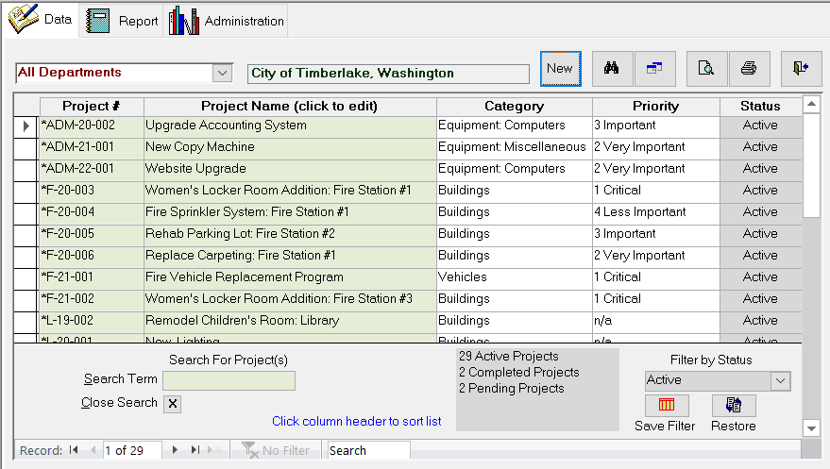
TO EDIT A PROJECT, DOUBLE CLICK ON THE PROJECT NAME (OR ANYWHERE ON THAT ROW) TO GET TO THE PROJECT DETAIL SCREEN; USE BINOCULARS TO RETURN TO DEPARTMENT PROJECT LIST
SELECT DEPARTMENT
DOUBLE CLICK ON ANY COLUMN TITLE TO SORT BY THAT COLUMN
YOU MAY FILTER TO VIEW ONE “STATUS” or “ALL” PROJECTS; TOTAL # OF PROJECTS OF EACH TYPE IS SHOWN
ENTER TEXT HERE FOR SEARCH; USE “X” TO CANCEL SEARCH
YOU MAY SAVE A FILTER AS YOUR ‘FAVORITE’ AND RESTORE TO THAT SETTING AT ANY TIME

ADDING/EDITING PROJECT DATA:

When the binoculars icon is selected from the Project List Screen or if you double click on a particular project, you enter the Project Detail Screen. Here, all details about a particular improvement or equipment purchase are entered or edited. Some icons appear as before:
- Binoculars icon – A toggle button between the Project Detail and Project List Screens.
- Pop-Out icon – View the Project Detail Screen in new pop-out window.
- Print Preview icon – Preview the Project Detail Report for this one project.
- Direct Print icon – Print Project Detail Report directly to printer with no preview.
REPORT PREVIEW/PRINT
- Door icon – Exit to the Opening Screen.
TOGGLE BETWEEN LISTS
POP-OUT PROJECT LIST
PROJECT DETAIL SCREEN
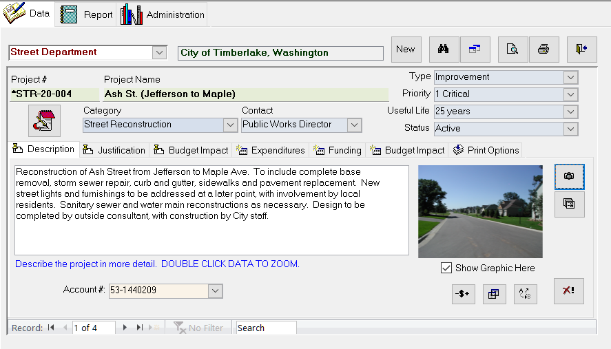
ADD A NEW PROJECT
MOVE FROM PROJECT TO PROJECT
MOVE ALL COST DATA FORWARD OR BACKWARD
DELETE
PROJECT
(Optional) VIEW GRAPHICS ON SCREEN
ADD or EDIT PROJECT NOTES
ASSIGN OR CHANGE GRAPHIC
CHANGE PROJECT STATUS
DUPLICATE PROJECT
MOVE TO DIFFERENT DEPARTMENT
ADD LINKS TO PROJECT DOCUMENTS
EXIT

ADDING PROJECTS
If you are working with the department for the first time, all fields will be blank, waiting for new project data to be added. Adding a new project is accomplished by clicking on the “New” button. You will be asked to assign a 12-character Project # that is unique to this project (e.g., ‘11-PW-003’). Using multiple digits for project numbers will help in keeping them lined up in the reports and give some historical perspective. Some reference to the Department (PW=Public Works), first year of the project (e.g., 11 for 2011), etc. may also be useful, so be creative with your project number. Make sure you give yourself enough digits for future additions to the project list (e.g., use ’09’ instead of ‘9’ to ensure correct sorting). This is an important number. In the Plan-It database, most data is tied to the project number. A blank screen will appear with fields for you to fill in.

ENTERING PROJECT DATA
Several fields should be completed, though most are optional:
- ‘Department’ – This was chosen already on the List Screen (projects may be moved to another department using the icon in the lower right corner).
- ‘Project Name’ – Enter a short description of the project.
- ‘Category’ – Choose the category this project is assigned to. Default is ‘Unassigned’.
- ‘Contact’ – Type the name of the person or organization responsible for this project. Job title is used most often, as it avoids editing if personnel change. If the response is not listed, just type it in and it will be added to the list and be available to be chosen in the future.
- ‘Type’ – Choose the ‘type’ this project is assigned to. Default is ‘Unassigned’.
- ‘Priority’ – The default choice is ‘n/a’ (which will show as a priority’0’ on reports). Select from the pull-down list an appropriate priority for the project.
- ‘Useful Life’ –Describe the expected useful life of this equipment or improvement. If the response is not listed, just type it in and it will be added to the list and be available to be chosen in the future.
- ‘Status’ – Designate as either ‘Active’ (the default) or one of the others as they were set up.
- ‘Show Graphics Here’ – Select to have graphics automatically show on the screen for each project. If this slows down your system too much, you can turn it off (but still view each graphic individually using the ‘camera’ button).
- ‘Move Costs’ (-$+) – Move all cost information forward or backward one year at a time. Default is to move expenditure, funding source and budget information – but you can select only some as well. Keep in mind that ALL costs will move to their new years, so be careful.
- ‘Duplicate Project’ – Create an exact copy of a project (will prompt for new Project # and Name).
- ‘Custom Fields’ – You can enter a value which applies to this project.
Once data for these fields are entered, proceed to the tabs in the bottom section to complete data entry.

ENTERING PROJECT DESCRIPTIONS
There are three text descriptions incorporated into Plan-It using a tab system:
- ‘Description’ – Enter text which describes the project in more detail.
- ‘Justification’ – Enter text which justifies the project.
- ‘Budget Impact’ – Enter text that describes the effect the project will have on annual budgets.
NOTE: When printed, text for these will appear in boxes within a limited space. Excessive text may result in having the box size grow, making the Project Detail Report a multi-page report.

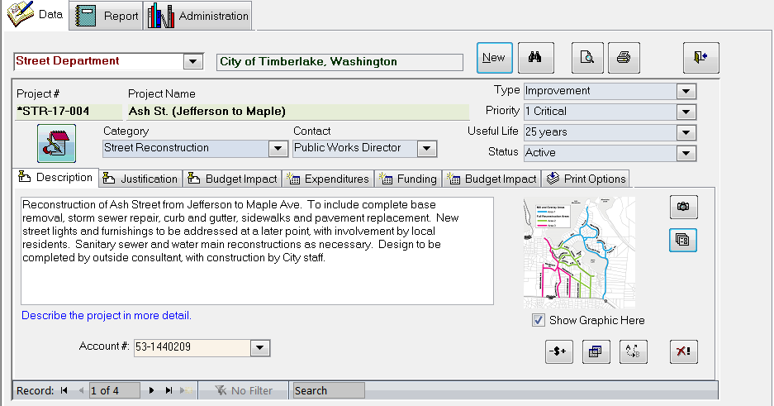
TYPE TEXT
CLICK TAB FOR TYPE OF TEXT YOU WISH TO ADD:
- Description
- Justification
- Operation Impact

ENTERING PROJECT COSTS
There are three types of financial data incorporated into Plan-It using a tab system:
- ‘Expenditures’ – Select the expenditure category, enter the cost (whole numbers) and select (or type) the year of each cost. NOTE: The year may be put in as “TBD”, meaning that you may not know when you will incur the expenditures. “TBD” project will not show on the expenditure reports, but will be detailed on the “Expenditure Exceptions” Administrative Group report.
- ‘Funding’ – Select the funding source, type the dollar cost and select (or type) the year of each cost.
- ‘Budget Impact’ – Select the budget category, input costs and select (or type) the year of each cost.
- ‘Print Options’ – All Project Detail Reports contain boxes that total costs outside the 5- or 10-year period (‘Prior Total’ and ‘Future Total’). If you would like these totals to NOT show on their Detail Reports, you can remove the checkmark here. The totals can be re-applied at any time. Also here are options to turn off “Total Project Cost” and the Budget Impact section (text and schedule).

If projects span more than one year or have different expenditure categories you must enter each combination on separate rows. Do not use the $ sign. Commas are added automatically. You can use the Tab key to move easily from one field to another. You need to include data for all three fields (e.g., Expenditure, Amount, and Year). If one data type is missing, you will be prompted to include it.

As dollars are entered, total expenditures and total funding amounts are shown, with any difference between the two noted. If you are out of balance between the two tabs, you will probably want to review your data and get in balance.

NOTE: You need to click out of the current tab for the total numbers to be updated.
If you wish to delete a data row click on the red “X” for that row (works for all the Expenditures, Funding and Budget Impact tabs). It will double check to make sure you want to delete that row.
HINT: You may enter them in any order, but it may be helpful to be consistent (e.g., grouped by years). Once entered, you can sort the data by any of the three columns. Just click on the column name (e.g., “Year”)
HINT: In selecting the year of the expenditure, you may select it using the pull-down feature (2007 to 2055) or you may manually type any year (2007 to 2055).

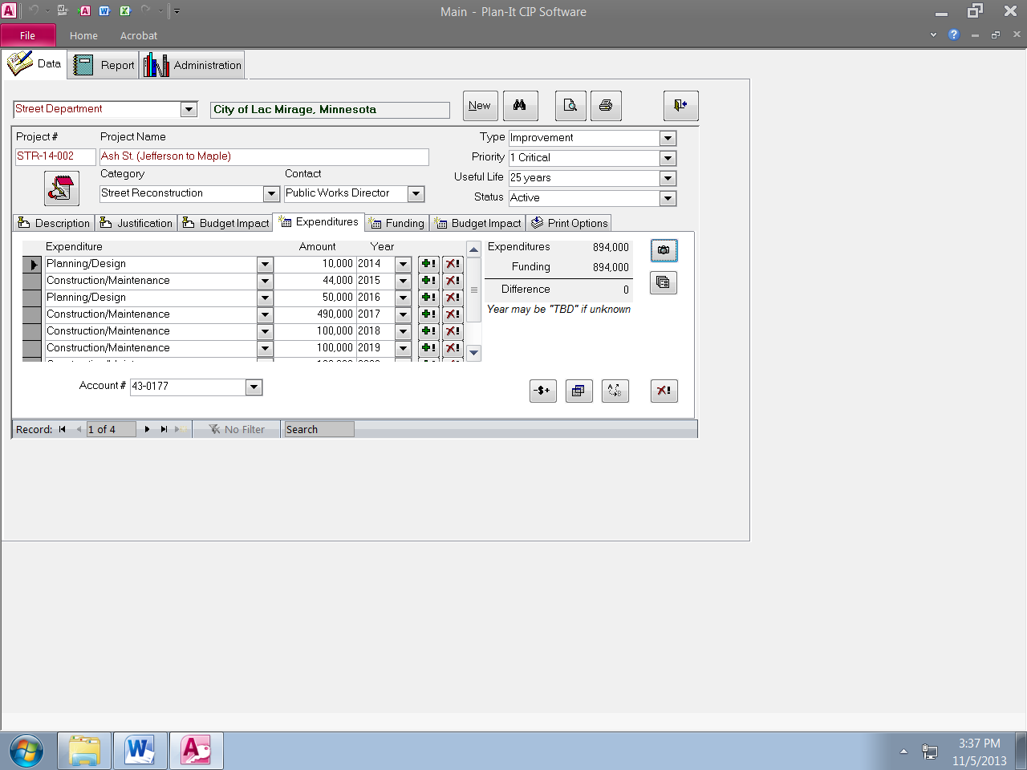
CLICK HEADER TO SORT BY COLUMN
SELECT USING PULL-DOWN
INPUTS AMOUNT AND YEARS
TOTAL EXPENDITURE AND FUNDING AMOUNTS ARE LISTED, WITH DIFFERENCES CALCULATED
TO DELETE A DATA ROW, CLICK THE RED “X”
USE THE “+!” BUTTON TO EXTEND OUT VALUES FOR ONE OR SEVERAL MORE YEARS
CLICK TAB FOR TYPE OF COST DATA YOU WISH TO ADD:
- Expenditures
- Funding
- Budget Impact

USING THE ‘EXTEND’ (+!) BUTTON
Often projects have expenditure, funding source or budget data that needs to be entered for several years (e.g., annual street paving). Plan-It allows you to input an initial row of data under any of these three areas, then extend that data for one or several years. Those future amounts can be increased by a fixed amount annually or a fixed percentage annually. This function populates data for your chosen number of years.

Start by clicking the Extend button (+!) for your baseline row. In the pop-up window, you can:
1) Input the number of years you want to add. It will add this data for consecutive years, based on your baseline row year. So if you clicked the Extend button for data in 2020 and told it to add four more years, the same dollars as in your baseline row would be added for 2021-2024 on four additional rows).
2) Input an annual increase amount (option). If you would like to increase the base cost by a fixed amount each year, enter a dollar amount (e.g., if 2000 was $10,000 and the increase is $1000/yr, the extended year values will be $11,000, $12,000, etc.).
2) Choose an (optional) inflation factor. If you would like to factor in an inflation rate to future costs, enter an inflation percentage. Dollars will be added as described above, but will be inflated. As before, your baseline dollar cost acts as the starting point for inflation calculations (e.g., at 5% inflation, 2020=$10,000, 2021=$10,500, 2022=$11,025, etc.).
NOTE: Both “Years to add” and “Inflation factor” values can be saved as the default by entering a value, then clicking the “Save Year Value” or “Save Inflation Value” buttons. So if you always consider 5% inflation, or always extend for four more years, you don’t have to retype it.
HINT: When inputting several years’ data that may not be in consecutive years, it may be faster/easier to enter one year, extend for several years, then delete unwanted data.

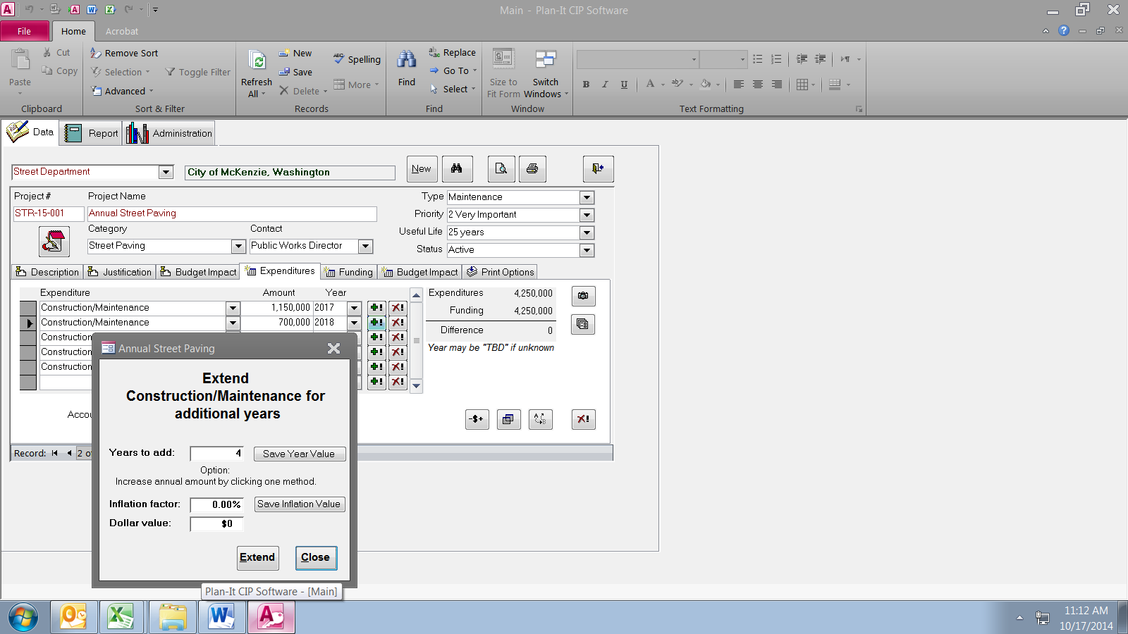
(Optional) INPUT THE ANTICIPATED ANNUAL INFLATION RATE OR FIXED DOLLAR VALUE
IF VALUES WILL BE USED REPEATEDLY, THEY CAN BE SAVED AS THE DEFAULT VALUE
INPUT THE NUMBER OF ADDITIONAL YEARS TO BE ADDED
1) CLICK EXTEND BUTTON ON ROW YOU WANT TO BE YOUR BASE YEAR (Works for all three dollar areas- Expenditures, Funding and Budget Impact

2) OPTION TO INCREASE ANNUAL COST either by a fixed amount or a %

GRAPHICS & DOCUMENT LINKS

ASSIGN GRAPHIC: Plan-It allows you to assign a graphic to each project. It may be a picture, a map, clip art or any other file that your system setup will allow. The steps to add a graphic are:
- Click on the Description tab (you will then see the graphics buttons).
- Click the graphics button (camera icon).
- From the form that pops up, browse to find the file you want to assign to this project (a default folder can be assigned in the Administration tab).
- When you select it by clicking ‘Open’, the graphic will have been assigned and a notice of assignment will appear.
HINT: It is recommended that all graphic files be put in a particular location (e.g., G:\PlanIt\Graphics) so they are easy to find. Plan-It does not actually incorporate the graphic file, but rather creates a link to the graphic file outside of Plan-It. So, if the graphic file is moved, you will need to re-link to it.
CHANGE GRAPHIC: If a graphic needs to be substituted, simply go through the steps above to assign the new graphic to the project.
ELIMINATE GRAPHIC: If you later choose to not include a project graphic, click on ‘Remove Graphic’, and then ‘OK’. This will take away the link to a graphic. A graphic may be reassigned at any time.

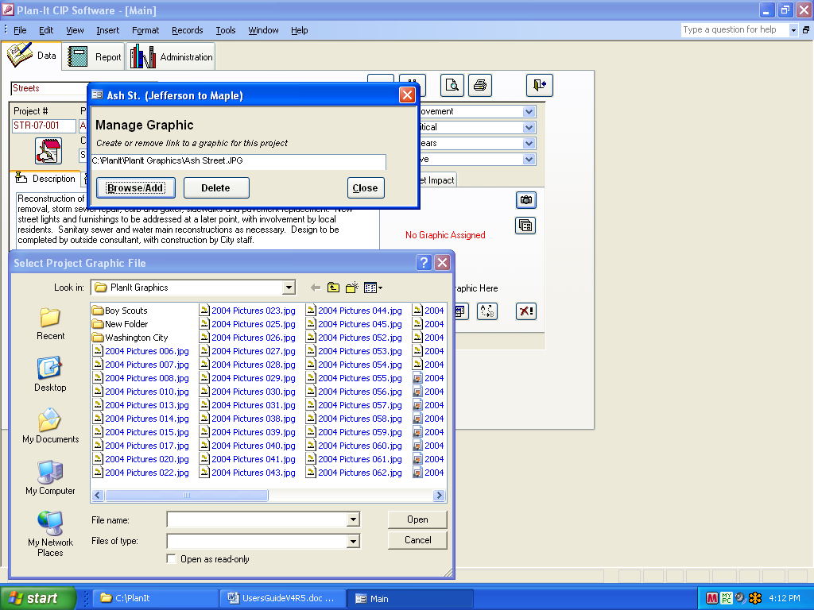
CLICK TO ASSIGN OR CHANGE A GRAPHIC FOR THIS PROJECT
UNASSIGN GRAPHIC
BROWSE FOR THE GRAPHIC FILE and CLICK “Open”
GRAPHICS STATUS IS GIVEN:
- ‘No Graphic Assigned’
- ‘Graphic Assigned’ (Graphic is linked but ‘Show Graphics Here’ is turned off)

MANAGE GRAPHICS:
Graphics can be added, edited or deleted in another way – from the Administration tab, Manage Documents button. From here, you can add or change several at a time, rather that one-by-one from the Data tab.

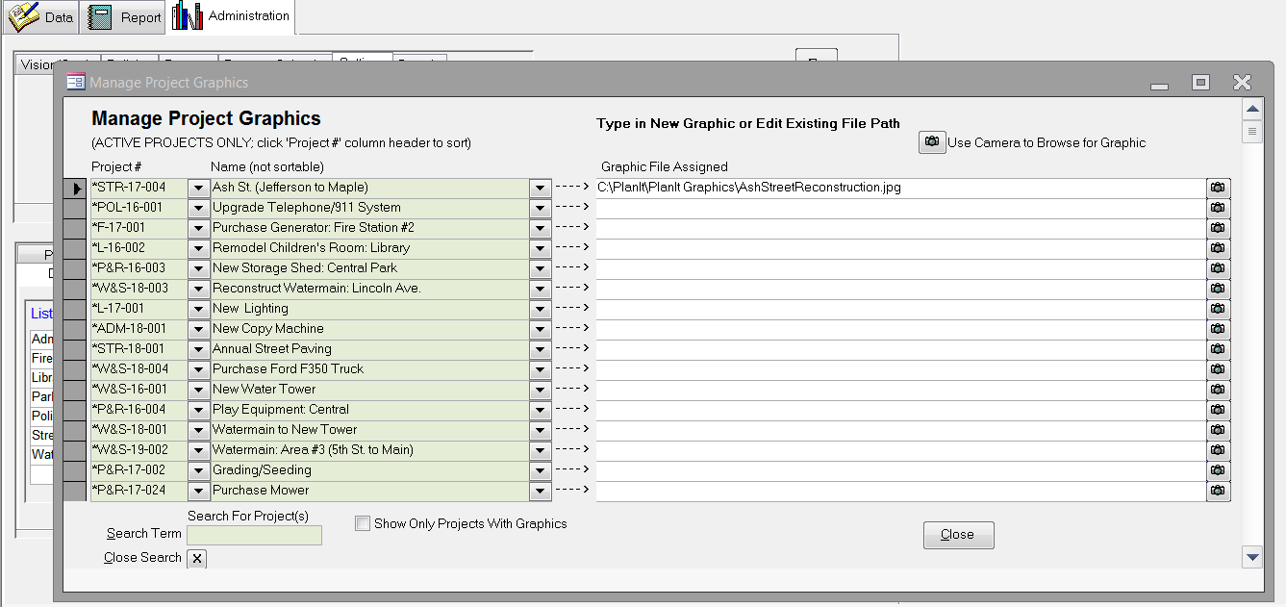
ADD, ENTER or EDIT GRAPHIC LINKS

ASSIGN DOCUMENTS: Plan-It allows you to assign links to documents for each project. They may be spreadsheets, work orders, engineer reports, invoices, status reports or any other file of interest on your system. The steps to add a document are:
- Click on the documents button (multiple-sheets-of-paper icon).
- From the form that pops up, click ‘Browse’ to go find the file you want to assign to this project.
- When you hit ‘Open’ on the browse screen, the graphic will have been assigned and added to the list.
- The documents button changes slightly when a document link is present to alert you to the fact that there is something to look at (adds a yellow ‘star’ to the icon).

HINT: Plan-It does not actually incorporate the document file, but rather creates a link to the document file outside of Plan-It. So, if document file is moved, you will need to re-link to it.
HINT: A default document path may be set up in the Administration tab.
CHANGE DOCUMENT: If a document needs to be substituted, simply go through the steps above to assign the new graphic to the project.
ELIMINATE DOCUMENT LINK: If you later choose to not list a project document, click on the document name, then click ‘Delete’. This will take away the link to a document. This document link may be reassigned at any time.

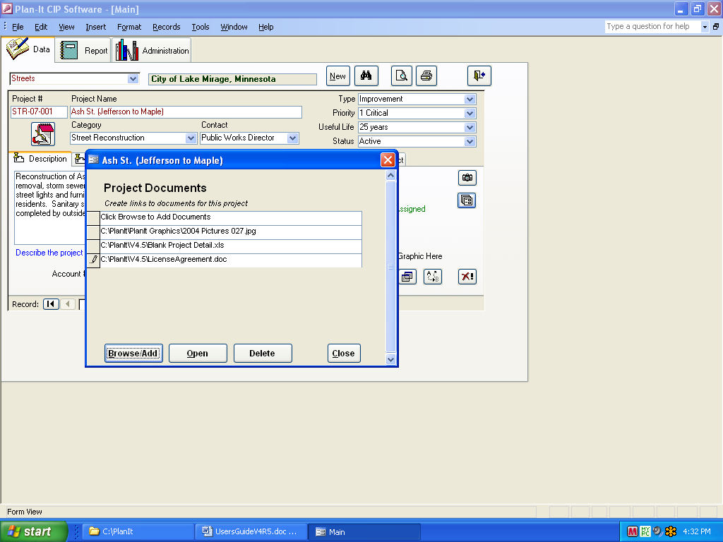
CLICK TO VIEW, ADD OR DELETE DOCUMENTS OF INTEREST FOR THIS PROJECT
ADD DOCUMENT LINK

VIEW DOCUMENT

DELETE LINK TO DOCUMENT (Select, then hit ‘Delete’)

CHECKING DATA ACCURACY

It is recommended that you check the accuracy of your work by doing a print of the Detail Project report. This is easily done from the Project Detail Screen by producing a Project Detail Report Preview:
- Click the magnifying glass icon from screens in the Data area.
- When the report appears, resize or scroll the resulting image to view your project’s data.
- The type of report you view is set in the Reports area (go to Reports tab, Project Detail Group, highlight your default report type, hit the “Set As Data Tab Default Report” button). This selected report then will show from the Data Tab preview and print buttons.

NOTE: Things to look for may include:
- Do the totals for expenditures equal the totals for revenue sources for the right years?
- Are the dollars in the right year?
- Has my text exceeded the allowed space, making it grow to a 2-page report?

- Click on “Close” (on tool bar) and you will return to the Project Detail Screen.

STANDARD PRINT AND RESIZING OPTIONS

CLICK TO CLOSE PREVIEW

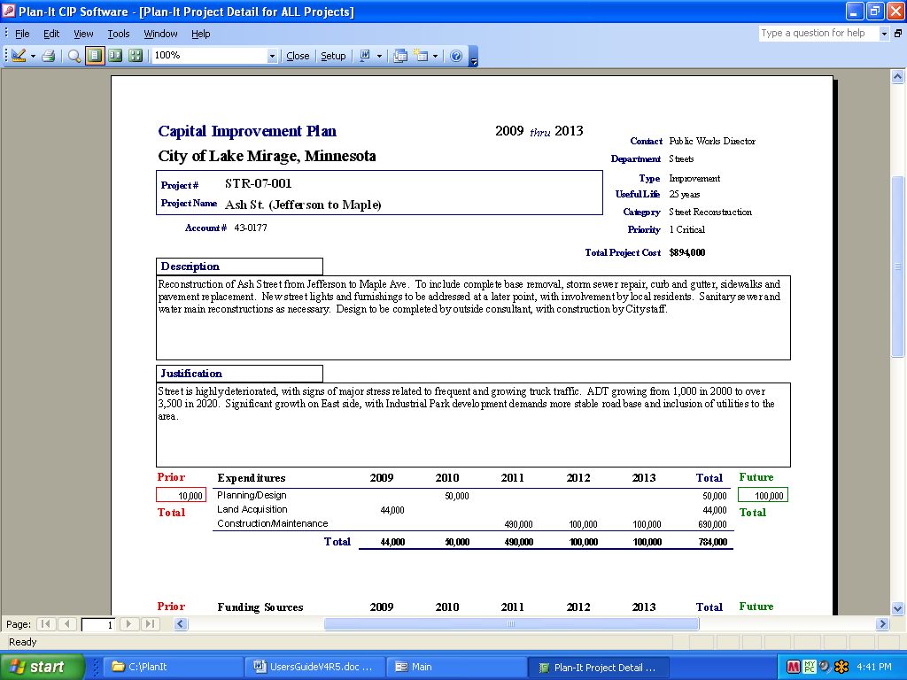
PROJECT DETAIL REPORT PREVIEW

MOVING FROM PROJECT TO PROJECT

There are three easy ways to move from project to project:
- On the Project List Screen, simply double click on the project name. The Project Detail Screen for the selected project will appear. To return to the Project List Screen and select a different project, click on the binoculars.
- Using the binoculars, return to the Project List screen. Scroll to where you can select the project you want to jump to. Click on the box in the left column () – it will turn dark gray. Click the binoculars to return to the Project Detail Screen for the selected project.
- Use the arrow buttons at the bottom of the Project Detail Screen to quickly move forward or backward to the next or previous project. You may also jump to another Department at any time from either screen.

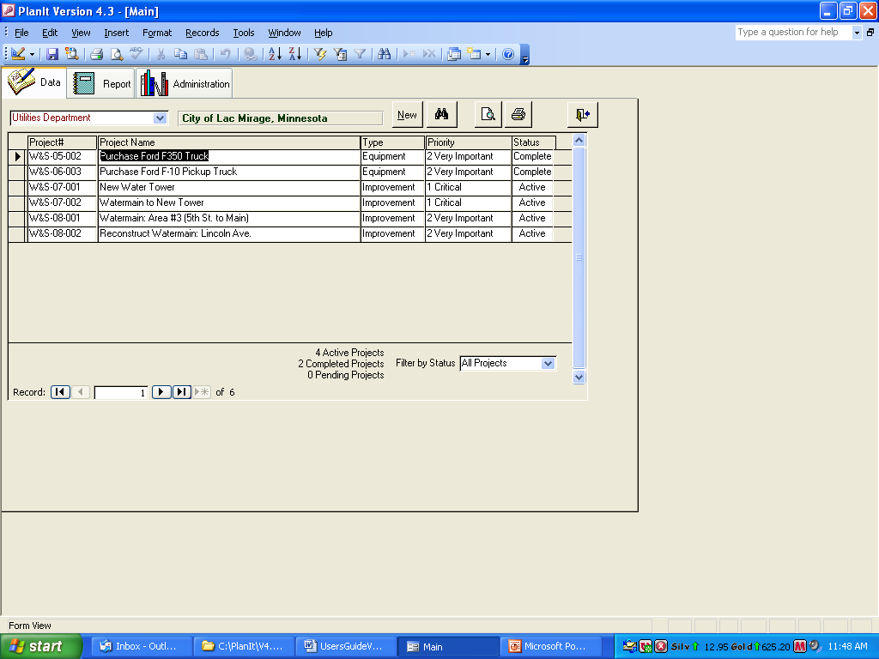
USE THE BINOCULARS TO TOGGLE BETWEEN THE LIST AND THE PROJECT DETAIL SCREENS
USE THE LIST SCREEN TO SELECT PROJECT FOR EDITING

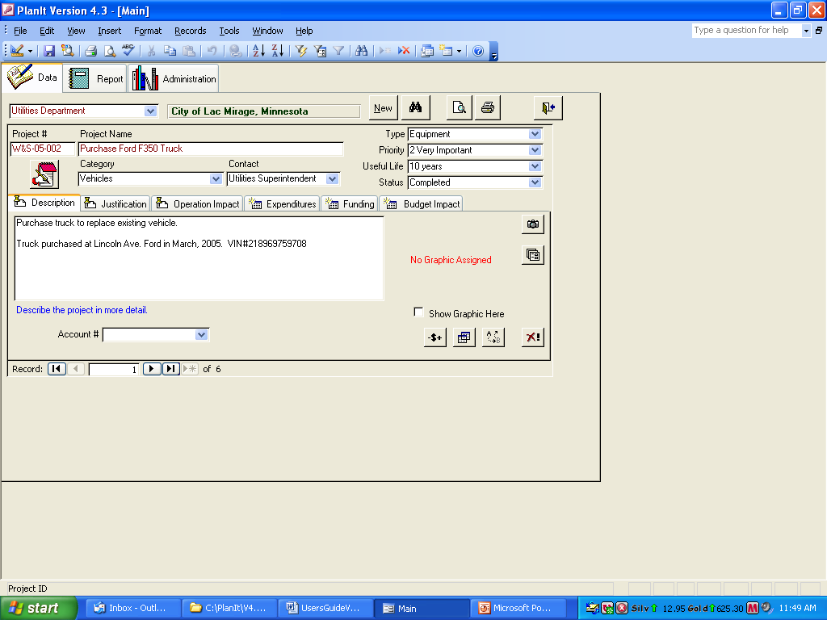
USE ARROWS TO MOVE TO PREVIOUS OR NEXT PROJECT
DELETE PROJECT USING “X”

DELETING A PROJECT
From the Project Detail Screen, simply click on the Project Delete button (the big red “X” at the bottom right). You will return to the Detail Screen, with data from the next project appearing. If you deleted the last project on your department’s list, you will see a blank screen.
HINT: Before deleting a project, think about if it would be better to change the project’s Status to “Completed” or “Pending”. Perhaps someone will want to read about the project in the future?
NOTE: It is nearly impossible to accidentally delete a project because there are four choices that need to be made before it is gone (select Department, choose the project, hit the ‘X’ and say “Yes”).

PRINTING REPORTS (current list of available reports):
**Indicates new report in Version 6,0

PROJECT DETAIL REPORTS:
Project Detail
Project Detail (6yr)
Project Detail (10yr)
Project Detail - Small Graphic #1
Project Detail – Small Graphic #1 (6yr)
Project Detail - Small Graphic #1 (10yr)
Project Detail - Small Graphic #2
Project Detail - Small Graphic #3
Project Detail - Small Graphic #3 (All yr)
Project Detail - Medium Graphic #1
Project Detail - Medium Graphic #2
Project Detail - Large Graphic (2 pg.)
Project Detail - Listing
Project Detail - Condensed

EXPENDITURE REPORTS:
Projects by Year
Projects by Year & Priority
Dept Summary
Dept Summary (10yr)
Projects by Dept
Projects by Dept (w/Desc)
Projects by Dept (10yr)
Projects by Dept (All yrs)
Projects by Category & Dept
Projects by Category & Dept (10yr)
Projects & Sources by Dept #1
Projects & Sources by Dept #1 (10yr)
Projects & Sources by Dept #1 (All)
Projects & Sources by Dept #2
Projects & Sources by Dept #2 (10yr)
Projects & Sources by Dept #2 (w/Desc,1yr)
Projects & Sources by Dept #2 (w/Desc,2yr)
Projects & Sources by Dept #2 (w/Desc)
Projects & Sources by Dept #2 (w/Desc,10yr)
Expenditures and Sources Summary
Category Summary
Category Summary (10yr)
Category Summary by Dept
Projects by Category
Projects by Category (10yr)
Projects by Dept & Category
Proj & Sources by Category
Proj & Sources by Category (10yr)
Expenditure Type Summary
Projects and Expend Types by Dept
Projects by Dept & Expenditure Type
Expenditure Type Summary by Dept
Expenditures by Custom Field
Project Listing
Text: Summary
Text: Descriptions
Text: Budget Impacts
Pending Projects

FUNDING SOURCE REPORTS:
Funding Source Summary
Funding Source Summary (10yr)
Funding Sources by Dept
Funding Sources by Dept (10yr)
Dept Expenditures by Source
Projects by Funding Source (1yr)
Projects by Funding Source (2yr)
Projects by Funding Source
Projects by Funding Source (10yr)
Projects by Funding Source (All yrs)
**Projects by Funding Source and Dept
**Projects by Funding Source and Dept (10yr)
Funding Sources by Category
Revenue Sources Summary
Sources and Uses – Summary
Sources and Uses – Summary (10yr)
Sources and Uses – Detail
Sources and Uses – Detail (10yr)
Text: Funding Source Descriptions

BUDGET REPORTS:
Budget Item Summary
Budget Item Summary (10yr)
Projects by Budget Item
Projects by Budget Item (10yr)
Projects by Budget Item (All yrs)
Projects and Budget Items by Dept
Budget vs Actual: All Years (LTD)
Budget vs Actual: One Year (YTD)

6-YEAR:
Dept Summary (6yr)
Projects by Dept (6yr) - Portrait
Projects by Dept (6yr) – Landscape
Projects by Dept and Category (6yr)
Projects by Category & Dept (6yr)
Projects & Sources by Dept #1 (6yr)
Projects & Sources by Dept #2 (6yr)
Projects by Category (6yr)
Funding Source Summary (6yr)
Projects by Funding Source (6yr)
**Projects by Funding Source and Dept (6yr)
Sources & Uses – Summary (6yr)
Sources & Uses – Detail (6yr)
Projects by Budget Item (6yr)

EXPORTS:
Project Dollars by Year
Project Dollars by Year (All Fields & Text)
Project Dollars by Year (All Fields)
Project Dollars by Source

ADMINISTRATION:
Project Notes
Project Graphics
Project Documents
Expenditure-to-Funding Exceptions
Administration Tab Text Summary
Administration Tab Setup Listing
Glossary

5) CLICK THE MAGNIFYING GLASS TO SEE THE REPORT PREVIEW OR DIRECT PRINT WITH THE PRINTER ICON BUTTON

1) SELECT
REPORT
GROUP
3) SELECT ALL THE CRITERIA YOU WISH TO USE TO LIMIT THE DATA INCLUDED
SET TYPE OF PROJECT DETAIL REPORT THAT WILL BE PRINTED FROM DATA TAB (Shows when in Project Detail Report Group list)
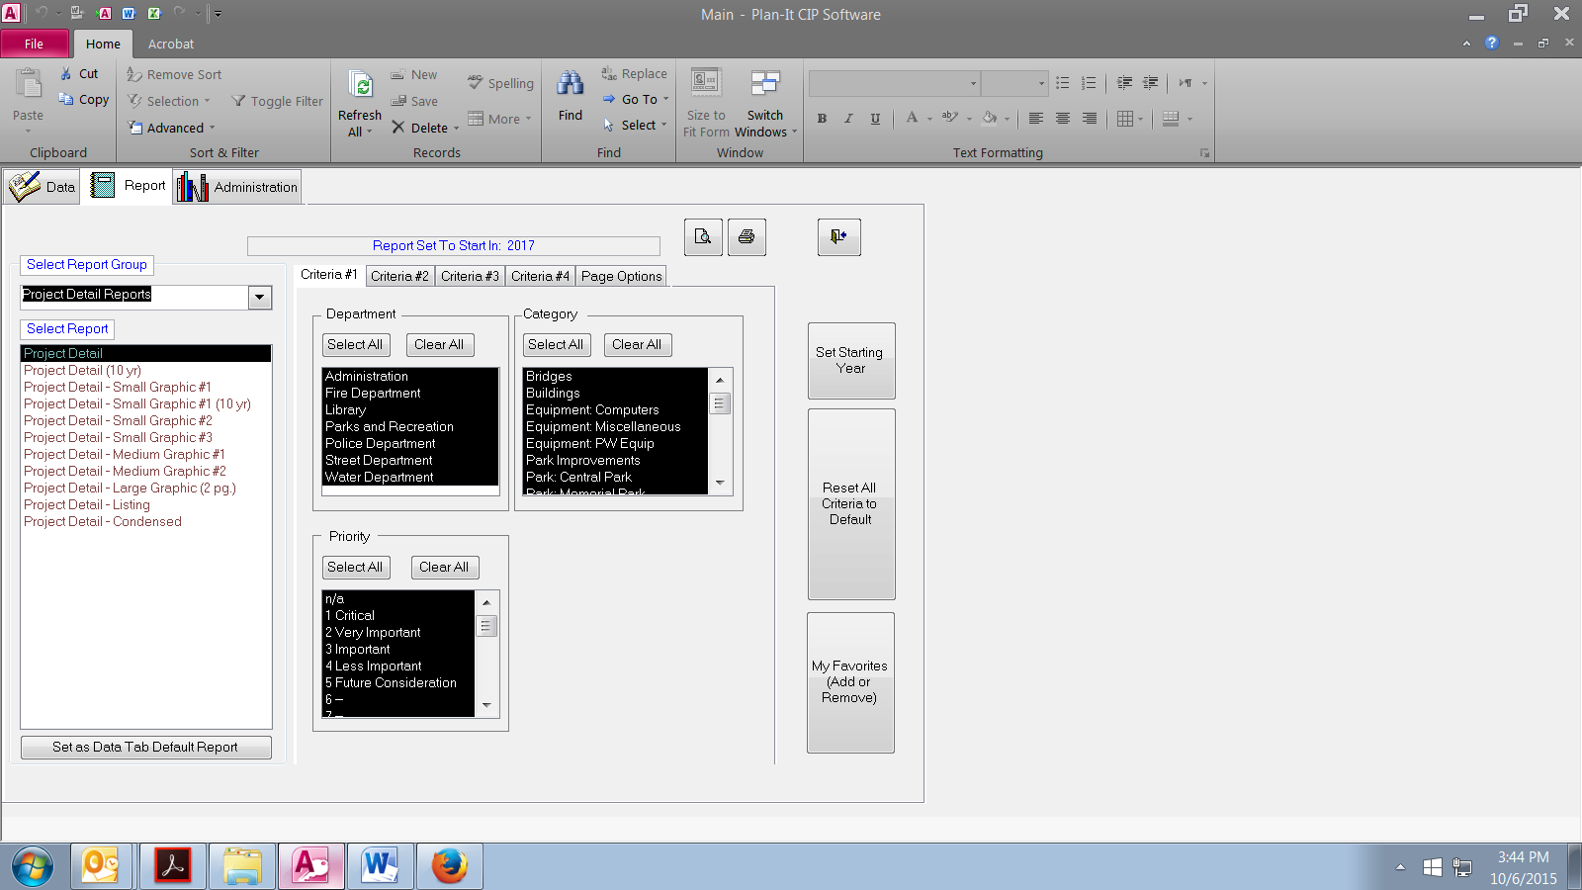
2) SELECT
REPORT
4) SET OTHER REPORT OPTIONS

Click REPORT to see the Report Screen. Click the report group for your report, then click the report you wish to print. Specify all criteria (see below for Criteria Tabs #1, #2 and #3), and Page Options; click the magnifying glass icon in the upper right hand corner.
NOTE: To save time, you may direct print using the button with the printer icon

PRINTING USING “CRITERIA #1-4” TABS

There are several ways you can limit the data included on any of the reports. They include:
CRITERIA #1 TAB
- ‘Department’ – Select the department or departments you wish to include. Default = All.
- ‘Category” – Select the category or categories you wish to include. Default = All.
- ‘Priority” – Select the priority of the projects you want included. Default = All.
- ‘Source’ – Available for Funding Source reports, you can print for one or many. Default = All.
CRITERIA #2 TAB
- ‘Status’ – Select the status(s) for projects you wish to print. Default = Active.
- ‘Type’ – Select the ‘Type’ designation(s) you wish to limit by. For example, this is useful in separating Equipment purchases from Improvement projects. Default = All.
- ‘Contact’ – Select the ‘Contacts’ you wish to limit by. Helpful in printing reports for one person, but multiple selections are allowed. Default = All.
- ‘Include on Report - Years’ – For the Project Detail Reports and Project by Year reports only, you can limit the reports to only those projects with financial data in the current 5-year period (set in Administration tab) or projects with financial data in a particular year (or years). This is useful in printing reports that have data for a particular year or set of years. Default = All Current 5 Years.
CRITERIA #3 TAB
- ‘Custom Fields’ – Select the field(s) you wish to limit by and select the value(s). Default = None. Fields may be set up in the Administration tab if no options show.
CRITERIA #4 TAB
- ‘Projects’ – Select or deselect projects you wish to include or not include. Default=All.

NOTE: Black means it is selected. Clicking will whiten the selections (to deselect).
NOTE: When the “Sources and Uses” reports are printed, you will see a warning window. This is to remind you to ensure that the ‘Year 1 Beginning Balance’ amounts entered in the Administration area (“Funding” tab) are the correct ones for the 5 year period you are printing.
NOTE OF CAUTION: With many printing options available, be careful to check all the criteria and de-select any that do not apply to your next print. All criteria options reset to the defaults each time Plan-It is accessed. A list of all the criteria options chosen (or all the defaults) can be printed at the end of each report. This allows you to know exactly what projects are included on each report.
HELPFUL HINT: Use the “Reset All Criteria to Default” button to reset every value to its original default.

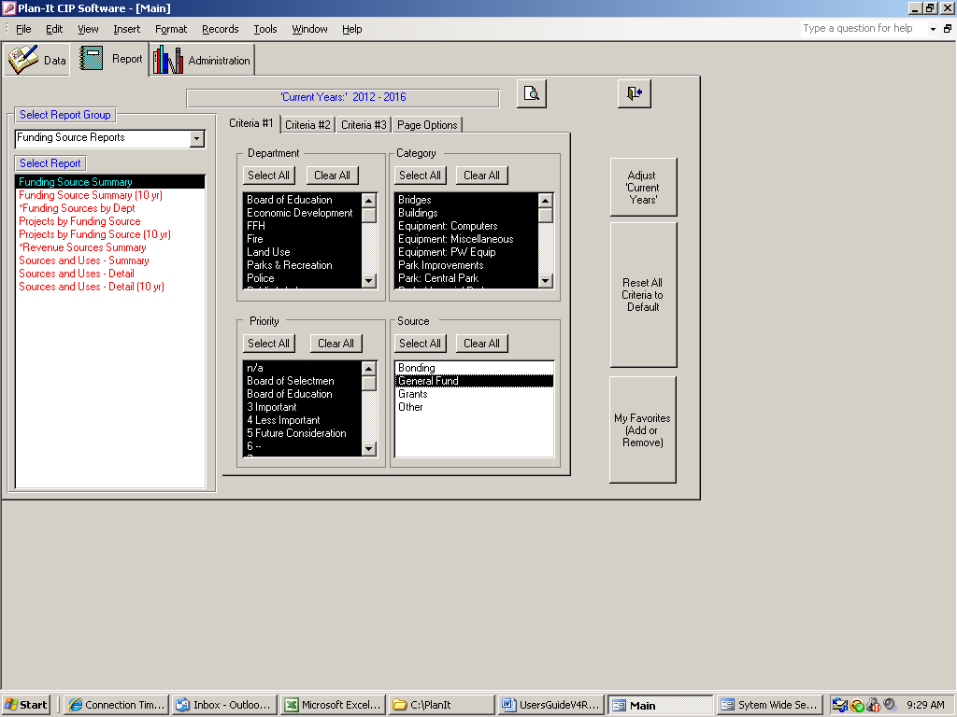
LIMIT THE DATA REPORTED USING MANY REPORT OPTIONS
RESETS ALL CRITERIA BACK TO THEIR DEFAULTS
ADJUST YOUR START YEAR DIRECTLY FROM HERE; SAVES TIME IN GOING BACK TO ADMINISTRATION TAB
SELECT AS MANY CRITERIA AS YOU WANT (#1,#2,#3&#4)
- Black is ‘Included’
- Multiple criteria is OK
ADD/REMOVE CHOSEN REPORT TO/FROM ‘MY FAVORITES’ LIST

‘MY FAVORITES’ LIST
Users can assemble a list of commonly used reports. Select a report then click the “My Favorites” button on the right. To take off the list, select, then click the button.

PRINTING USING “PAGE OPTIONS” TAB

After clicking on the “Page Options” tab, there are several ways you can change the look of what is included on any of the reports. They include:
- ‘Date’ in footer - Turn on or off depending on your needs. Default = On.
- ‘Budget Schedule’ - There are two formats for each Project Detail Report. One will include space for the Budget Impact Schedule, the other will not (making more space for all the other project information). If you are not tracking budget information or have any text in the Operation Impact field, turn off this function. It eliminates a lot of white space at the bottom and makes the font in the text boxes larger.
- ‘Include Total Project Cost’ - Turn off the printing of ‘Total Project Cost’ on Project Detail Reports.
- ‘Report Criteria’ - If you want to print the criteria you selected (lists at the end of each report) click this on. Default = Off
- ‘Custom Fields’ - If you do not want to show your custom field data to show on Project Detail reports, turn this off. Default = On.
- ‘Include Prior/Future Dollars’ - You can turn off the ‘Prior Total’ and ‘Future Total’ boxes on Project Detail reports.
- ‘Include Priority’ – You can turn off the ‘Priority’ headers and values on all reports.
- ‘Include Status’ – Have the project’s ‘Status’ show on Project Detail Reports; default is ‘no show’
- ‘Date Style Option” - Select the way you want the years to show on reports (2018, FY ’18, FY18 or ‘18/’19). Default = Calendar Year (e.g., 2018).
- ‘Report Title’ - Change as desired. Default = “Capital Improvement Plan”.
- ‘Report Footer’ - Change as desired. The text will show up on the left side of each page footer. Default = “Produced using the Plan-It Capital Planning Software”.

NOTE: All changes made in this area remain until changed at a later time (THIS IS DIFFERENT THAN THE IN THE OPTIONS #1 and OPTIONS #2 TABS). If multiple people are using Plan-It, changes one person make will impact others, so caution should be taken.

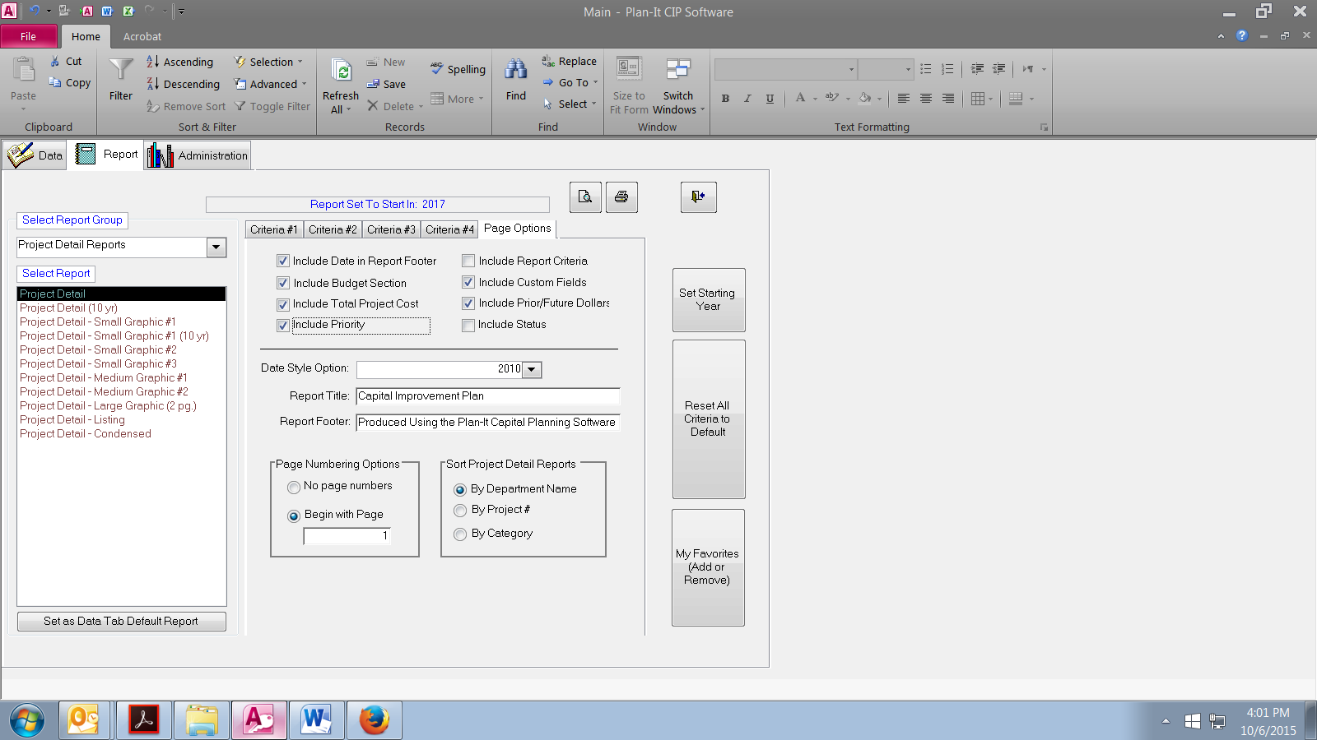
SET AS MANY PAGE OPTIONS AS YOU WANT
- Will remain set until changed - Page number returns to “1”
after each print
SET SORT ORDER FOR WHEN PRINTING PROJECT DETAIL REPORTS

PAGE NUMBERING
For each report, you may choose to begin at a designated page number. Just click on “Begin with page” and type in the appropriate number. Page numbers may also be turned off completely using the other option.
SORT PROJECT DETAIL REPORTS
Select if you want project sheets to print in order of Department, Project #, Category Project Name.

PREVIEW REPORTS:

After completing the previous report printing steps, Plan-It reports will appear on the screen automatically within a few seconds (depending on the report, the amount of data and your computer’s processor speed).

At this point, you can do several things using standard Microsoft operations:
- Resize the reports using the toolbar menu
- Place more than one report page on the screen at a time using the toolbar menu
- Move from page to page using the “Page” icons at the bottom of the screen
- Zoom in to the report using the magnifying glass icon

PRINTING
To obtain a hard copy report for all pages:
- Click on the toolbar printer icon or select the standard Microsoft File/Print options.
To obtain a hard copy report for a specific page:
- Determine the pages to be printed. Then use the standard Microsoft File/Print menus to print only the pages you are interested in.
Exit by clicking on the ‘Close’ button on the toolbar.
HINT: Many users are using .pdf writer software to create .pdf files of reports. These are useful in sending the report to someone (fax or email), compiling a CIP book or uploading reports to websites.

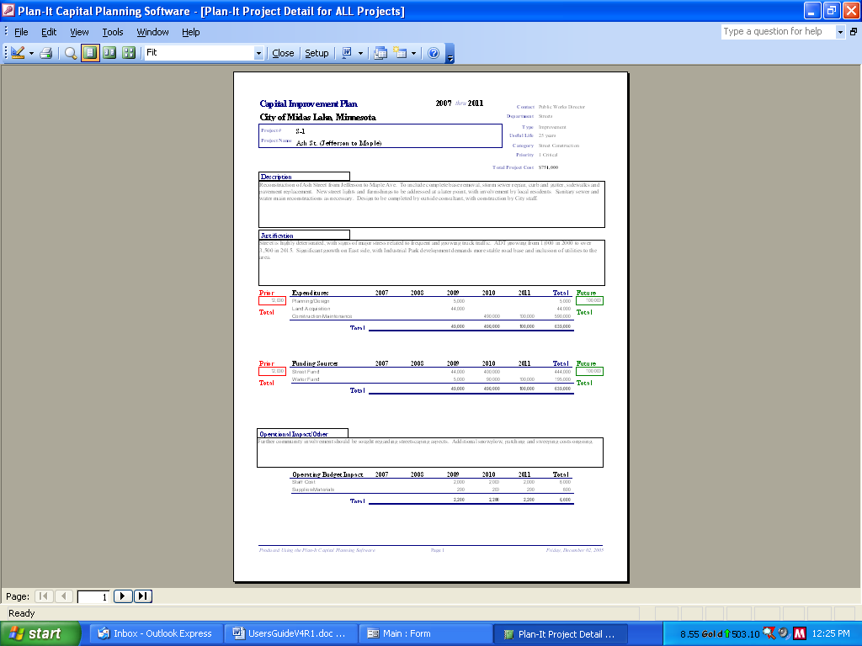
CLICK TO EXIT (CLOSE) REPORT PREVIEW
MOVE FROM
PAGE TO PAGE
STANDARD PRINT AND RESIZING OPTIONS

ENTER DATA FOR ‘BUDGET vs ACTUAL’ REPORTS:

As an optional enhance function, Plan-It has the ability to save “Actual” expenditure data and print reports that summarize payments made on that project (“Actuals”) compared to what is listed in the CIP (“Budgeted”).
1) Click the “Add/Edit Actuals” button in the Administration Tab. This opens the data entry form.
2) Select a project (either by Project # or Name). Only projects with a Status of “Active” are eligible.
3) Enter the “Actual” amount you wish to see appear on the Budget vs. Actual reports.
4) Assign a year for that “Actual” amount.
NOTE: If a project is deleted in the Data tab, it’s corresponding entry in the “Actual” table will be deleted automatically. This helps keep your list up to date.

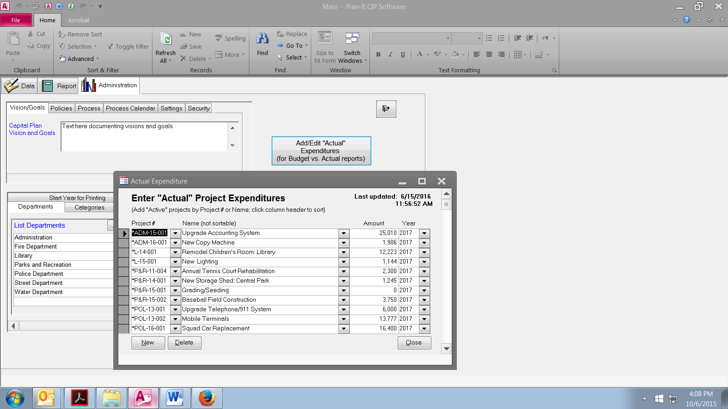
1) CLICK TO OPEN “ACTUALS” DATA INPUT FORM
2) BUILD LIST OF PROJECTS WITH THEIR “ACTUAL” VALUES; MAY LIST DOLLARS FOR MULTIPLE YEARS

PRINT “BUDGET vs ACTUAL” REPORTS
There are two reports that will analyze the imported expenditure data against the amount budgeted in Plan-It. The reports, located in the “Budget Reports” group” in the Report tab are:
- “Budget vs Actual: One Year (YTD). This report lists projects that have an expenditure amount assigned to the chosen year, shows that expenditure amount and the “Actual” amount spent on the project so far in that year. Some particular items apply to this report:
  - Select the year to print by altering the “Start Year for Printing”. This can be done from either the Report tab or the Administration tab. Whatever you set as your “Start Year” will be the year that is printed.
  - If a project has budgeted amounts for the year but no “Actual” amounts, it will show on the report.
- “Budget vs Actual: All Years (LTD). This report lists all projects, shows the total budgeted expenditures and the amount spent, in all years, over that project’s “Life-To-Date” so far. Keep in mind that only projects with a Status of “Active” will be printed.

SECURITY SETTINGS

Plan-It has a sophisticated security capability built into the base product. import data from a pre-set Excel spreadsheet and print reports that summarize payments made on that project (“Actuals”) compared to what is listed in the CIP (“Budgeted”).

TURN OFF SYSTEM-WIDE SECURITY
If there is only one user at a location or for any other reason it seems reasonable to turn off the username/password requirement, this may be done. Steps to disable the entire security system include:
- Log on to Plan-It using the username and password supplied by Strategic Insights (this is different from the “1” and “Plan” used by you currently. A separate username and password are supplied only upon request so Strategic Insights Inc. has some control over who can alter or dismantle your security options).
- Go to the Administration tab; click on the “Security” tab.
- Click on the “General Security Settings” box
- Change the “Enable System-wide Security” option to “No”, then exit Plan-It.
The next time you enter Plan-It, there will be no username and password boxes – just click the finger icon and you are in!

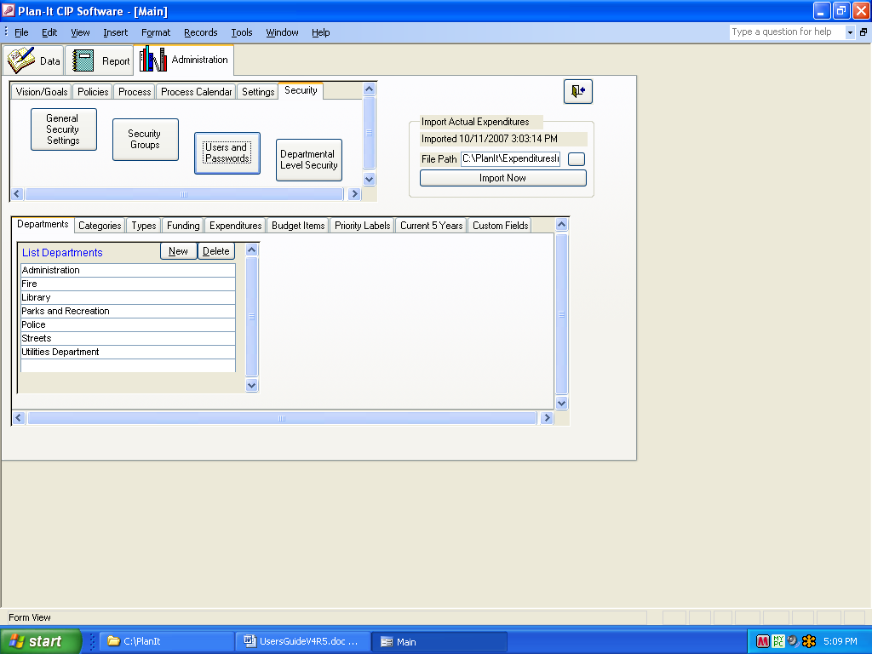
ENTER PLAN-IT USING THE ADMINISTRATOR’S USER NAME AND PASSWORD SUPPLIED BY STRATEGIC INSIGHTS;
THEN CLICK HERE TO DISABLE SECURITY

ENABLE USER-LEVEL SECURITY
If there are multiple users at a site and there is a concern about the ability of one person or department’s ability to either change data in the Administration tab or alter data from another department, it may be desirable to set up user-level security. With this enabled, people can be assigned unique usernames and passwords of your choice and given rights to view and edit various areas of Plan-It or types of data. Changes to these security settings may be altered at any time by the administrator of your Plan-It system.

To enable and edit user-level security:

- Log on to Plan-It using the username and password supplied by Strategic Insights (this is different from the “1” and “Plan” used by you currently. A separate username and password are supplied only upon request so Strategic Insights Inc. has some control over who can alter or dismantle your security options).
- Go to the Administration tab; click on the “Security” tab.
- Click on the “Security Groups” box. The default setting was to have two groups – one for the administrator and one for users (the administrator group cannot be changed for technical support reasons).
- Create or delete groups as necessary using the boxes on the left side. This may be used to grant similar rights to a logical group (e.g., all people in Public Works).

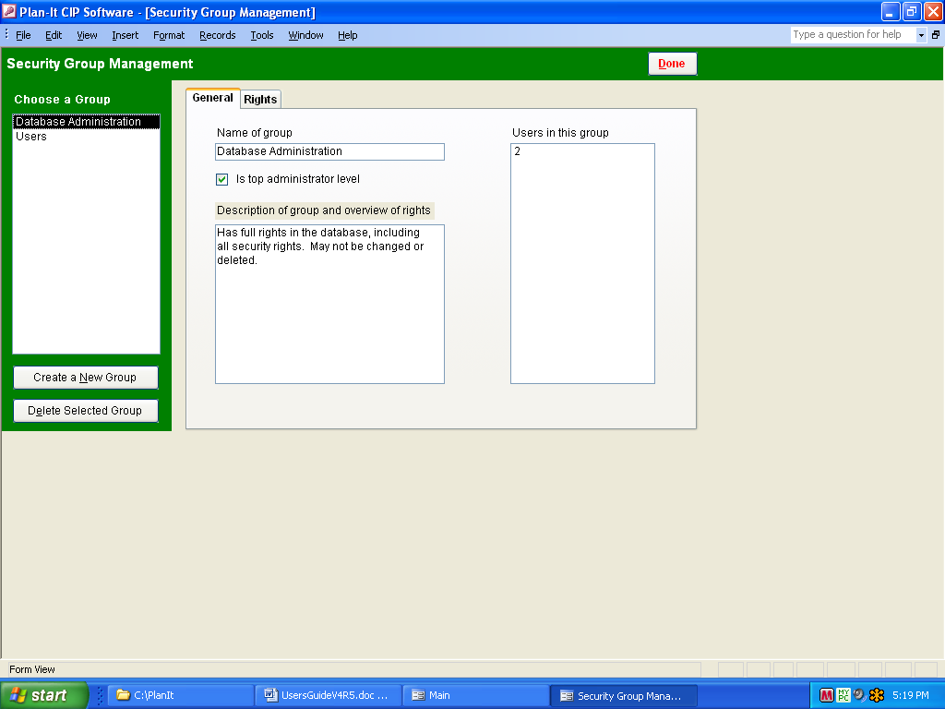
ASSIGN RIGHTS TO THE CHOSEN GROUP
CREATE OR DELETE A GROUP

5) By clicking on the “Rights” tab, the selected group may be allowed to either view or edit or be restricted from viewing or editing three areas – the Administration tab, the Data tab or the area where security options are set up.

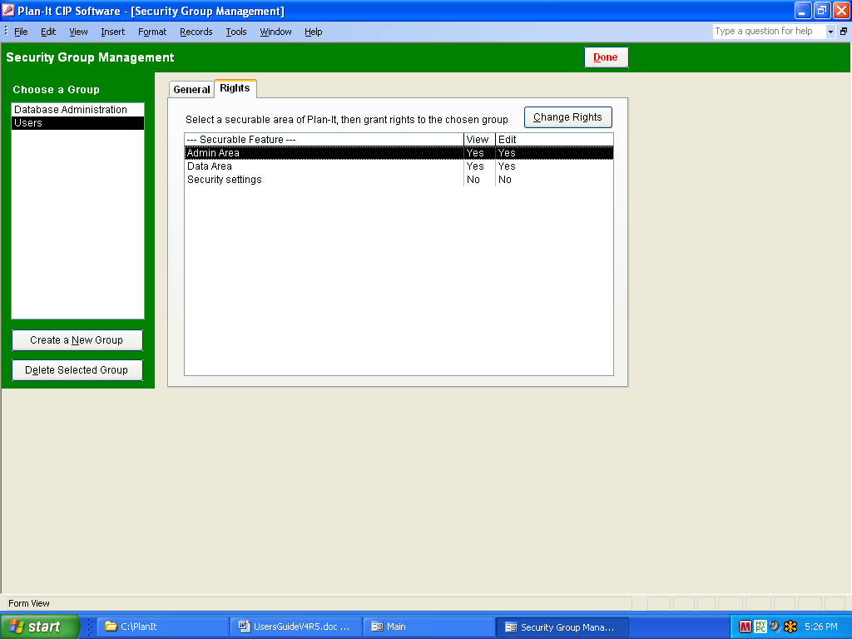
CHOOSE TO RESTRICT A GROUP’S VIEWING AND/OR EDITING RIGHTS TO KEY PLAN-IT AREAS OR CAPABILIIES

6) By clicking on the “Change Rights” tab, the group is either allowed to view or allowed to edit data in the chosen area (e.g., restricting users from being able to change project data in the Data tab).

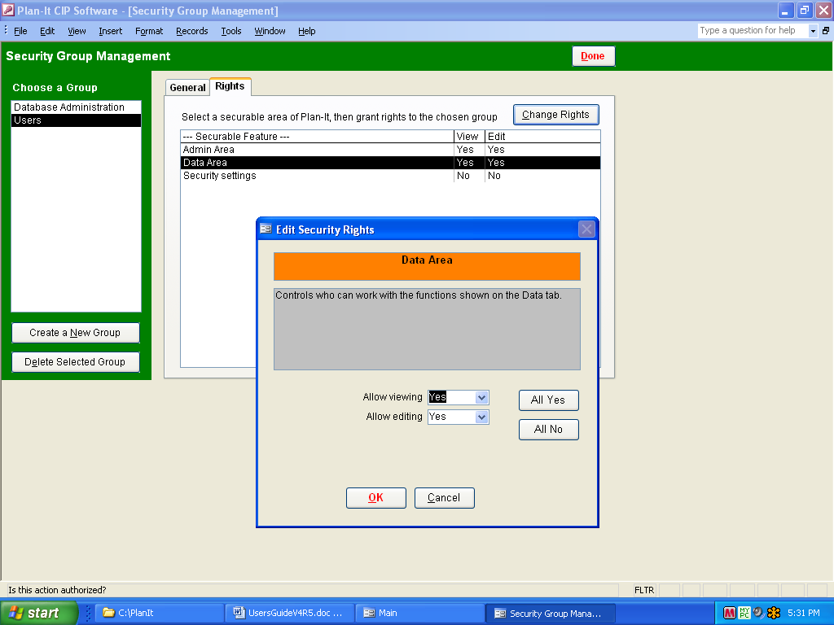
CLICK TO GET TO ‘CHANGE RIGHTS’ POPUP WINDOW

- By clicking on the “Users and Passwords” tab, you may define the various user names and passwords that are to be used to enter Plan-It. Anything from “John S” to “HungryMan3” may be set up. You will notice that the Administrator’s default may not be deleted. This is to ensure that we may always enter Plan-It and the security area for technical support. An appropriate security group should then be assigned to each new user.

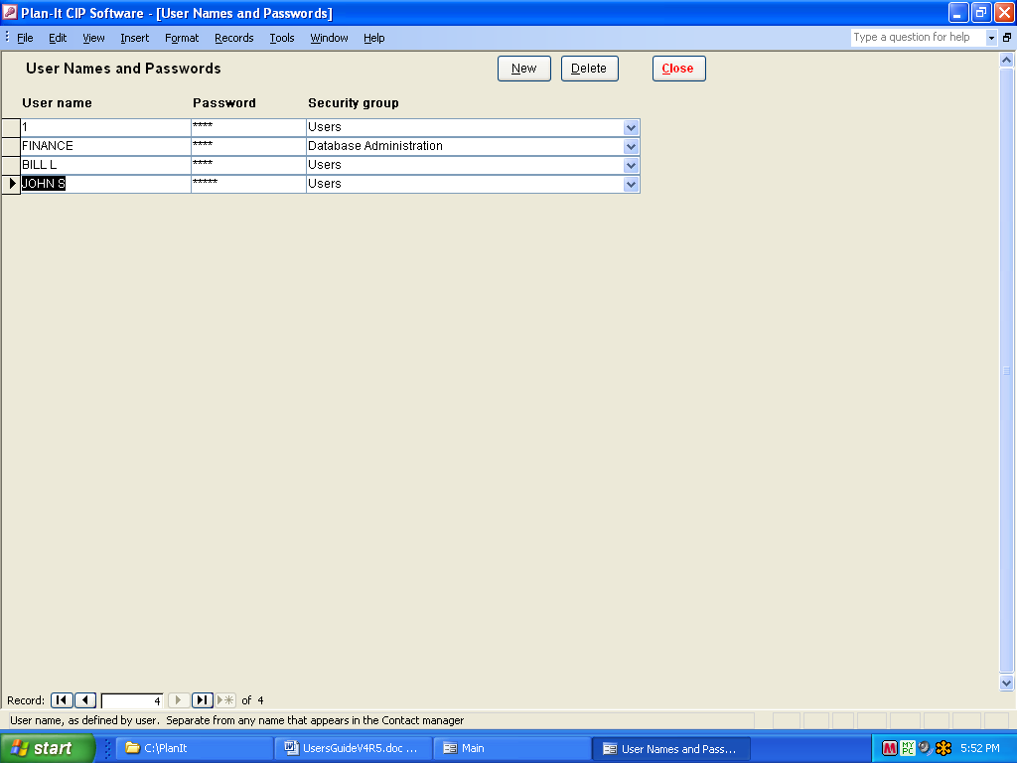
ENTER USER NAMES AND PASSWORDS FOR GROUPS OR INDIVIDUALS

- By clicking on the “Departmental Level Security” tab, you may restrict each user from viewing and/or editing data from particular departments. For instance, you may want user “John S” to only be able to view, not edit, data from the Fire and Police department.

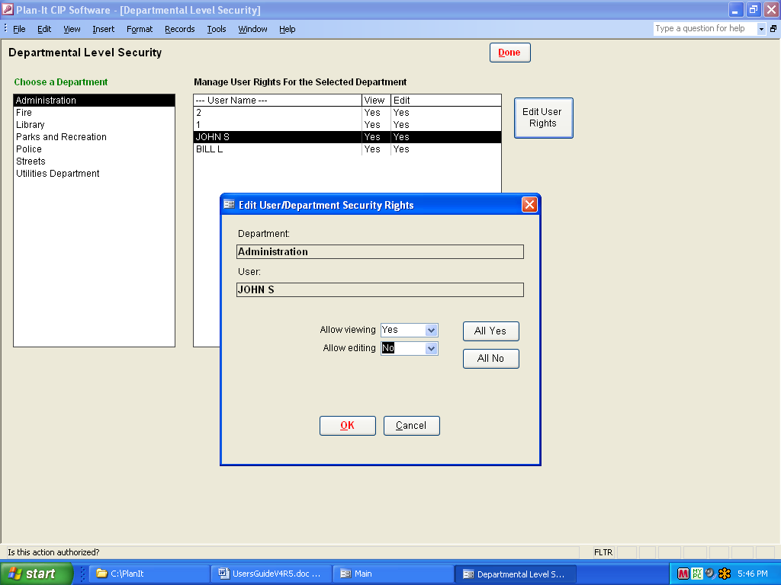
RESTRICT VIEWING OR EDITING RIGHTS ON A DEPARTMENTAL BASIS

PLEASE GIVE US A CALL IF YOU NEED TO KNOW THE ADMINISTRATOR’S USER NAME AND PASSWORD, OR IF YOU HAVE ANY QUESTIONS!

THANK YOU
FOR CHOOSING Plan-It!©

Strategic Insights Inc.
840 Timberlake Way
Bellingham, WA 98229
(952) 994-1744

bleskee@CIPsoftware.com

© Plan-It is a copyright of Strategic Insights Company. Any duplication or unauthorized use of the software is prohibited.

Important:
You must accept the License Agreement supplied to you before you can use this product. The product is licensed as a single product for installation at one site. It may not be duplicated for use outside the intended site. If you do not accept the terms of the License Agreement, you should promptly return the product for a refund.

